

Course: Digital Literacy
Submitted by: Raina Gupta
Registration Number: 25BCE10822

TASK-2 — DIGITAL PORTFOLIO

Objective of Task-2
Create professional online presence by setting up and optimizing digital profiles and learning safe online behaviour.
- LINKEDIN PROFILE
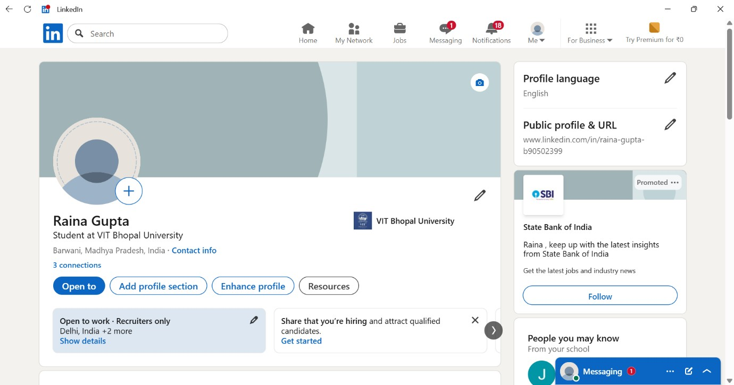

- GITHUB PROFILE

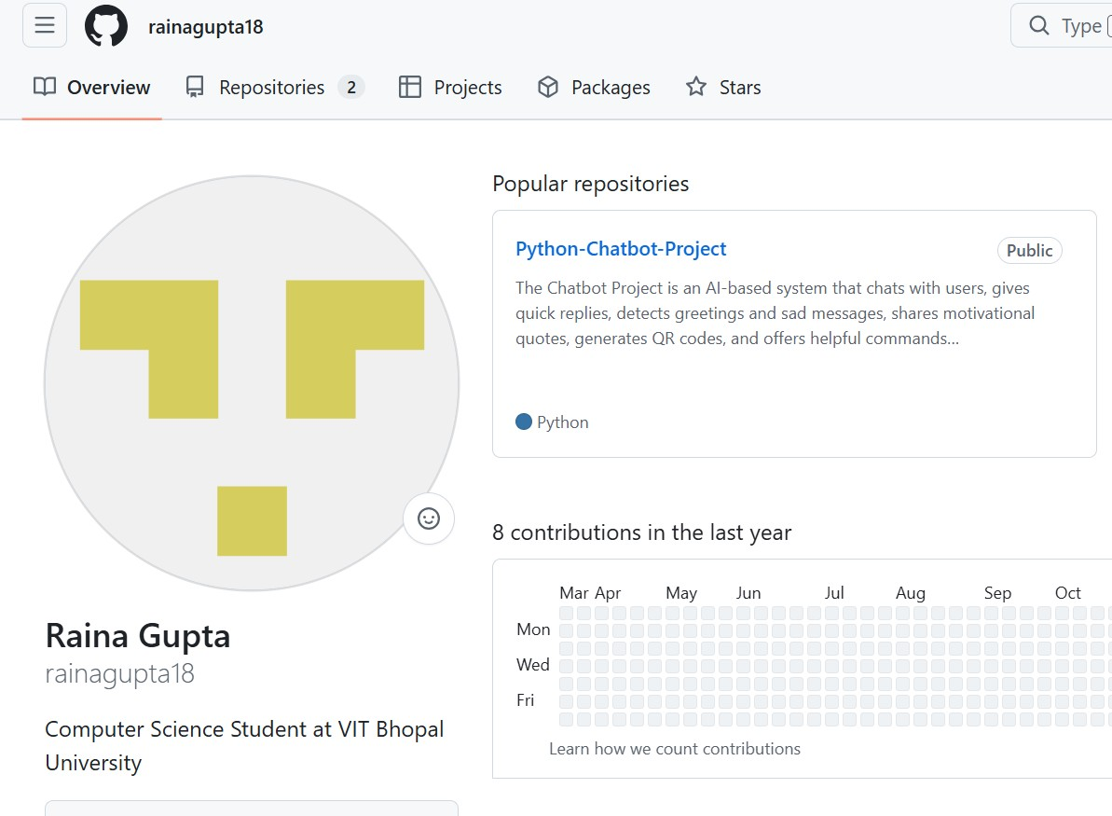

1. What I Learned
Creating professional profiles helped me understand the importance of digital identity. I learned how employers and institutions view students online and how a well-maintained profile creates a positive impression.

I understood the difference between personal and professional online presence.
2. Importance of Professional Profiles

Professional profiles:
- Build credibility
- Help in internships/jobs
- Show skills and achievements
- Create networking opportunities

LinkedIn helps in networking, while GitHub helps showcase projects and technical work.

3.How This Task Improved My Digital Skills This task improved:
- Online communication
- Professional branding
- Digital confidence
- Awareness of online safety
Now I feel ready to maintain a strong professional online presence.
4. Conclusion

This task was very helpful in understanding digital responsibility and professional networking. These profiles will help me in future academic and career opportunities.

